



Product Request Specification (PRS) Form Version 0.2

Customer Name: TOLL Global Logistics

Project Name: LEGO China RDC

Author & Company: TOLL

Date: 09/12/2017



Contents

Product Request Specification (PRS) Form 3

Document Revisions 3

Summary of Business Problem 4

Summary of Impacted Roles 4

Summary of New Requirements 5

Detailed Requirements 5

Use Cases 6

Assumptions 7

Performance Considerations 7

Definitions and Glossary 8

Workarounds and Alternatives Considered 8

Solution Proposals (Optional) 8

Product Request Specification Approvals 9

Project Sponsor Signoff 9

Stakeholder Signoff 9

About JDA Software, Inc. 9

# Product Request Specification (PRS) Form

| Product Request Specification | | **All fields are required** | |
| --- | --- | --- | --- |
| Title: | Double-Pallet Putaway Extension | | |
| Product and Version: | JDA 9.1.x | | |
| JDA Reference: | **[Jira Number]** | | |
| Client Reference: | N/A | | |
| JTRAX Project Code | N/A | | |
| Client Information: **(This contact will be used for the required review meetings with JDA.)** | Client Name:  Contact:  Title:  Phone:  E-mail: | | TOLL GLOBAL LOGISTIC |
| Sam Ho |
| Project Manager |
| Sam.Ho@tollgroup.com |
| Requested Timeframe: | September, 2017 | | |
| Installation Owner:(Client or JDA) | JDA | | |
| Number of environments: | 3 | | |
| Related modification? | NO | | |
| Is an active JDA Consulting team on site? | YES (through September 8th only) | | |

## 

## Document Revisions

|  |  |  |
| --- | --- | --- |
| Revision Number | Revision Date | Changes Made |
| 1.0 | 2/114/2017 | Initial Document |
| 2.0 |  |  |

## Summary of Business Problem

Toll’s LEGO warehouse Regional DC stores pallets and picks pallets and cases. Physical storage is primarily racking, where the ground level stores one pallet, the second and third level store two pallets (double stacked), and the top level stores a single pallet.

As RDC receives stock directly from the factory, receiving is often sequenced by SKU. Pallets are double stacked when unloading into the staging lane, and then are putaway by MHE supporting double-stack putaway.

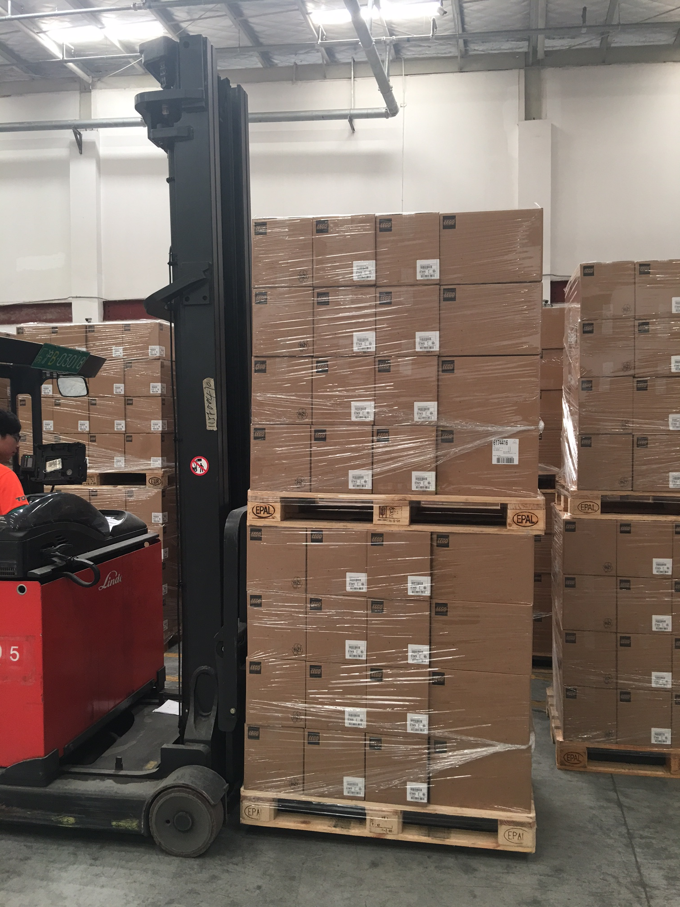

**Double Pallet (Stacked) Mover**

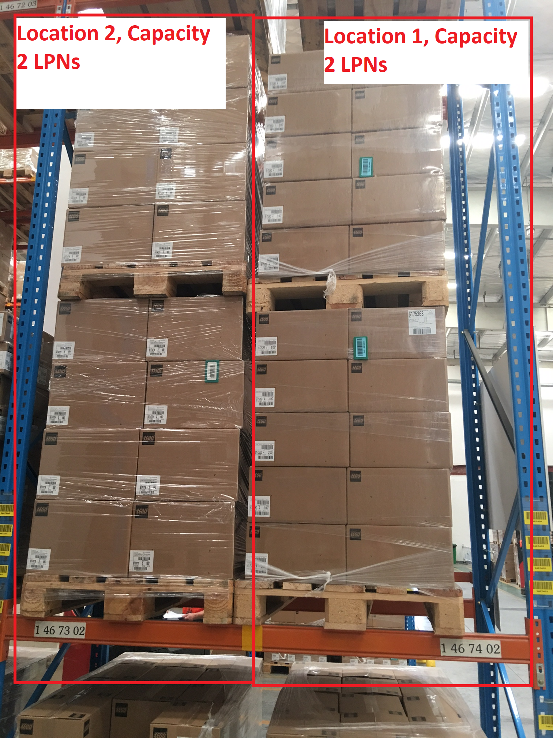

**Double Pallet Storage Location**

Operations requires the system to direct double stacked pallets of the same SKU into a single double-pallet location, whenever available and allowable based on mixing rules, storage zone UoMs, etc.

The WMS currently allocates locations one pallet at a time, often ignoring these opportunities and forcing users to split the stack during putaway. The traffic caused by splitting in aisles also increases congestion, impacting outbound operations.

## Summary of Impacted Roles

* Logistics Associate, Inbound Team Lead

## Summary of New Requirements

When an operator uses the RF Putaway Screen, the system should detect whether this is the second LPN being scanned to the device. If two pallets are on the device, the system should use a new set of putaway rules for both pallets, attempting to store them together.

If this is not possible because there are no double locations left, the SKU is the incorrect velocity, or co-location would violate mixing rules, then the pallets should be stored separately as per current rule-set.

The functionality should be configurable and extensible, ideally using the same storage search path method that drives putaway in the standard product. It should support ‘keep zone’ and ‘break zone’, storage search path criteria, and Source-Proximity Putaway.

## 

## Detailed Requirements

| **Req. Number** | **Requirement Description** |
| --- | --- |
| 1.0 | Different storage rules should be used when storing a single pallet versus two pallets. |
| 1.1 | Double Pallet rules should drive both LPNs to the same location, provided there are no mixing rule violations. |
| 1.2 | Double pallet rules should support Keep Zone and Break Zone functionality |
| 1.3 | Double pallet rules should utilize Search Path Criteria (Client ID, UDIAs, etc) as in standard rules |
| 2.0 | When double pallet rules fail, the system should revert to allocating a location one LPN at a time. |
| 3.0 | System should allow configurable ordering, for example both of the following should be possible: (see 3.1, 3.2) |
| 3.1 | Storage Sequence:  Find Double Pallet storage – Keep Zone  Find Double Pallet Storage – Break Zone  Find Empties – Keep Zone (split double pallet into two locations, i.e. standard logic)  Find Empties – Break Zone (split double pallet into two locations, i.e. standard logic) |
| 3.2 | Storage Sequence:  Find Double Pallet Storage – Keep Zone  Find Empties – Keep Zone (split double pallet into two locations, i.e. standard logic)  Find Double Pallet Storage – Break Zone  Find Empties – Break Zone (split double pallet into two locations, i.e. standard logic) |
| 4.0 | Within a given set of locations, the system should respect source proximity putaway. For example, if there is more than one available double pallet location, the system should continue to sort by distance to Source staging location. |
| 5.0 | In all cases, mixing rules must be respected. If the two pallets being stored by an operators cannot be stored together based on mixing rules, the pallets should be stored separately. |
| 6.0 | Rules should be configurable by Warehouse and Client ID |

## 

## Use Cases

This section is used to provide a list of use cases that will be used to validate the solution.

| Case Number | Case Description | Expected Results |
| --- | --- | --- |
| 1.0.1 | Use RF Putaway to store a single LPN | System follows standard behavior |
| 1.1.1 | Use RF Putaway to store two LPNs at the same time (vehicle limit >=2). | System uses new rule set and attempts to store pallets together. |
| 1.2.1 | Configure a double pallet rule for ‘Keep Zone’. Disable all ‘A’ velocity locations. Attempt to store two ‘A’ velocity LPNs. | System does not allocate a location using this rule. |
| 1.2.2 | Configure a double pallet rule for ‘Keep Zone’. Attempt to store an ‘A’ product. Enable ‘A’ velocity locations. Attempt to store two ‘A’ velocity LPNs. | System allocates the same location for both pallets in the ‘A’ Zone. |
| 1.2.3 | Configure a double pallet rule for ‘Break Zone’. Disable all ‘A’ velocity locations. Attempt to store two ‘A’ velocity LPNs. | System allocates the same location for both pallets in the ‘B’ or ‘C’ Zone. |
| 1.3.1 | Configure a double pallet storage rule which is dependent on INV_ATTR_STR6. Scan two LPNs with INV_ATTR_STR6 matches the inventory storage search path. | Two LPNs are stored in the same location using the Double Pallet storage rule. |
| 1.3.2 | Configure a double pallet storage rule which is dependent on INV_ATTR_STR6. Scan two LPNs with INV_ATTR_STR6 does not match the storage search patch. | The two LPN’s do not find locations using the new Double Pallet Storage rule |
| 2.0 | Configure a double pallet storage rule and regular storage rule lower in the storage search path. Disable all 2 capacity locations. Scan two pallets for putaway | The two LPN’s are stored in separate locations. |
| 4.0 | Configure a double pallet rule. Configure two double pallet locations with STO_SEQ = 100 and STO_SEQ = 200. Configure a Receiving lane with STO_SEQ = 0 and STO_SEQ = 100.  Receive two LPNs into the receiving lane with STO_SEQ = 0. | The two LPNs are stored in the location with STO_SEQ = 100. |
| 4.1 | Configure a double pallet rule. Configure two double pallet locations with STO_SEQ = 100 and STO_SEQ = 200. Configure a Receiving lane with STO_SEQ = 0 and STO_SEQ = 100.  Receive two LPNs into the receiving lane with STO_SEQ = 1000. | The two LPNs are stored in the location with STO_SEQ = 200. |
| 5.0 | Configure a zone with an available double pallet location and putaway rules to support. Configure mixing rules to disallow mixed Vendor IDs. Attempt to store the double pallet. | The two pallets are stored separately. |
| 6.0 | Validate existing rules for other clients and warehouse are unaffected by change. | No effect from change. |

## Assumptions

* Effected locations are tracked by LPN (Capacity Code = Pallet)

## Performance Considerations

None.

## Definitions and Glossary

Not applicable

## 

## Workarounds and Alternatives Considered

* The process and system design attempts to store in partials before empties. In principal, this will cause the second LPN scanned to be directed to the same location as the first. However, in actual practice, a single partial location will throw off the logic, such that the first pallet fills the partial and second starts a new partial location.
* Use of a double LPN footprint.

## Solution Proposals (Optional)

*SUGGESTION ONLY. Complexity of change unknown.*

Create a new storage rule type in addition to ‘Use Empty’ and ‘Use Partial’ (called Location Status in 9.1+):

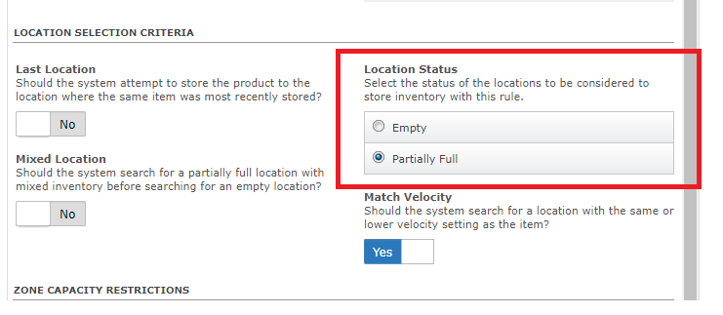

Create a new command ‘list var double locations for storage’ (in addition to the standard ‘list partial locations for storage’ and ‘list empty locations for storage’). This command only returns rows if the LPN being allocated is on the same device as another LPN, and it only returns locations with sufficient capacity for both LPNs on the device.

If this rule finds a location, a value is placed on the stack. A trigger is added to ‘allocate location’ which looks for the stack value, and if found, allocates the first pallet on the device to the same location as the second (allocate location where lodnum =’<LODNUM2>’ and stoloc = ‘<STOLOC1>’ and wh_id = ‘<WH_ID>’)

# Product Request Specification Approvals

### Project Sponsor Signoff

|  |  |
| --- | --- |
|  | |
| Customer Sponsor signature Date: | JDA Sponsor signature Date: |
| Customer Sponsor (Print Name) | JDA Sponsor (Print Name) |

### Stakeholder Signoff

|  |  |
| --- | --- |
|  | |
| Stakeholder #1 signature Date: | Stakeholder #2 signature Date: |
| Stakeholder #1 (Print Name) | Stakeholder #2 (Print Name) |

(Add additional names, signature lines, date lines if more approvals are necessary)

## 

## About JDA Software, Inc.

At JDA, we’re fearless leaders. We’re the leading provider of end-to-end, integrated retail and supply chain planning and execution solutions for more than 4,000 customers worldwide.  Our unique solutions empower our clients to achieve more by optimizing costs, increasing revenue and reducing time to value so they can always deliver on their customer promises.  Using JDA, you can plan to deliver. www.jda.com